Nautical Bowls LLC  Application for Employment |  |  |  |  |  |  |  |  |  | 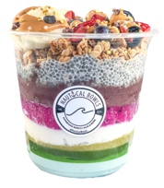  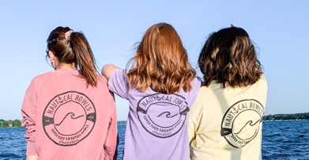 |  |  | 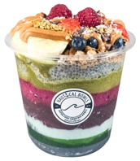
Personal Information
Name
Address |  |  |  |  |  |  | City |  |  | State |  |  | Zip
Phone Number |  |  | Mobile Number |  |  |  | Email Address
Position
Position You Are Applying For |  |  |  |  |  |  | Available Start Date
DECK HAND
Employment Desired
 |  |  | Full Time |  |  |  | Part Time |  |  | Seasonal/Temporary
Shift Availability- Summer Season morning shifts are 8am-2:30pm. Evening shifts are 2:30pm-8:30pm. Catering & Event hours differ.
 | Monday |  |  | Tuesday |  | Wednesday |  | Thursday |  |  | Friday | Saturday |  | Sunday
Morning
Evening
Education
School Name |  |  |  | Location |  |  | Years Attended |  |  | Degree Received |  |  | Major
[
References
Name |  |  |  |  |  |  | Title |  |  | Company |  |  | Phone
Employment History
Employer (1) |  |  |  |  |  |  | Job Title |  |  |  |  |  | Dates Employed
Work Phone |  |  |  |  |  |  | Starting Pay Rate |  |  |  |  |  | Ending Pay Rate
Address |  |  |  |  |  |  | City |  |  | State |  |  | Zip
Employer (2) |  |  |  |  |  |  | Job Title |  |  |  |  |  | Dates Employed
Work Phone |  |  |  |  |  |  | Starting Pay Rate |  |  |  |  |  | Ending Pay Rate
Address |  |  |  |  |  |  | City |  |  | State |  |  | Zip
More About Yourself
b
Do you value a healthy and fit lifestyle? If so, explain how:
What are your best characteristics, strengths, or traits that make you a desirable applicant?

Why do you want to work at Nautical Bowls?

How many times have you been into Nautical Bowls? What is your favorite combo?

What keeps you coming back to Nautical Bowls?

I certify that my answers are true and complete to the best of my knowledge.
If this application leads to employment, I understand that false or misleading information in my application or interview may result in my release.

Name (Please Print) |  |  |  |  |  |  | Signature
Date

